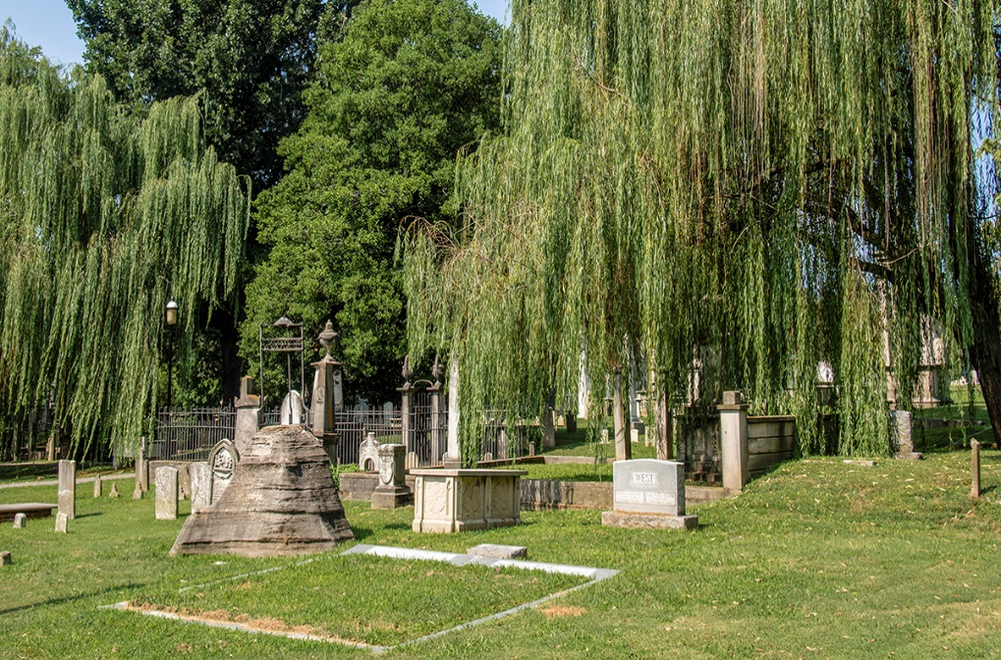

|  |  |  |  |  |
| --- | --- | --- | --- | --- |
| Nashville City Cemetery  Where the history of Nashville rests | | |  | July 30, 2022 |
|  | | |  | **Come visit the burial cites of war generals, senators, and past Nashville mayors.**  **Or come pay respects to more than 1800 slaves who are buried here** |
| The most common reasons for burial in the cemetery are cholera and consumption  During the mid 1800’s consumption(now know as tuberculosis) and multiple cholera outbreaks attributed to almost 3000 burials alone. That’s quite high considering the population of Nashville during that time |  |  | | |